Name: ____________________________________________________________ Date: ______________ Period: ______

Chemistry in Earth System: Quarter 1 Midterm Review

The midterm is on __________________________________________. The purpose of the midterm is to measure retention of information we have learned so far in quarter 1.

This review packet is due on ___________________________________.

**Important midterm information:**

* The midterm will be multiple choice & cumulative—it will cover everything so far.
* You will *not* be able to retake the midterm, and it will *not* be curved.
* The midterm will account for 10% of your overall grade (for now, it will be averaged with the final at the end of the semester)
* You will get to use your Conversion (DA Reference) Cheat Sheet and a calculator on the test.
* You may make a notecard (3x5, both sides) of notes to use on the midterm. You may put whatever information you would like on this notecard, but it will be collected along with your test.

**LT 1.1: Identify standard units and use dimensional analysis to convert between them.**

1. How many liters are in 4.78 gallons? Show work, write your answer with units and correct significant figures.
2. Convert 489.1 mg to kg. Write your answer in scientific notation. Show work, write your answer with units and correct significant figures.
3. How many inches are in 3.7 kilometers? Write your answer in scientific notation. Show work, write your answer with units and correct significant figures.
4. How many micrograms (μg) are in 3.5 grams? Show work, write your answer with units and correct significant figures.

**LT 1.2: Calculate answers with the correct number of significant figures and units, using scientific notation as appropriate.**

1. Give the rules for counting significant figures.
2. How many significant figures are in each of the following numbers? Underline all of the significant figures.
   1. 351 _________
   2. 402 _________
   3. 309000 _________
   4. 0.0041 _________
   5. 0.020900 _________
   6. 5010.0 _________
   7. 18900 _________
   8. 60. _________
   9. 4.5 x 103 _________
   10. 3.10 x 10-1 ________
3. When multiplying and dividing, how do you determine how many significant figures your answer should have?
4. For each of the following calculations, give your unrounded answer, then a rounded answer with appropriate units.

|  |  |  |
| --- | --- | --- |
| **Calculation** | **Unrounded Answer** | **Rounded Answer** |
| 43 g x 0.06 g |  |  |
| 3056 m3 ÷ 410 m2 |  |  |
| 0.0051 mL2 x 5.67 mL2 |  |  |
| 35.10 cm x 0.44 cm x 5.111 cm |  |  |
| 400 g3 ÷ 35 g |  |  |
| 16.789 kg ÷ 7.1 kg x 2.10 kg |  |  |
| 1400 m2 ÷ 650 m |  |  |

1. In scientific notation, how many numbers should be before the decimal point?
2. In scientific notation, what does a positive exponent mean? A negative exponent?
3. Convert the following numbers into scientific notation:
   1. 3,400 ___________________________
   2. 0.000023 ________________________
   3. 101,000 ________________________
   4. 0.010 _________________________
4. Convert the following numbers into standard form:
   1. 2.30 x 104 ________________________
   2. 1.76 x 10-3 _______________________
   3. 1.901 x 10-7 ______________________
   4. 8.65 x 10-1 _______________________
   5. 9.11 x 103 ________________________

**LT 1.3: Analyze the accuracy and precision of experimental data and analyze experimental error.**

1. 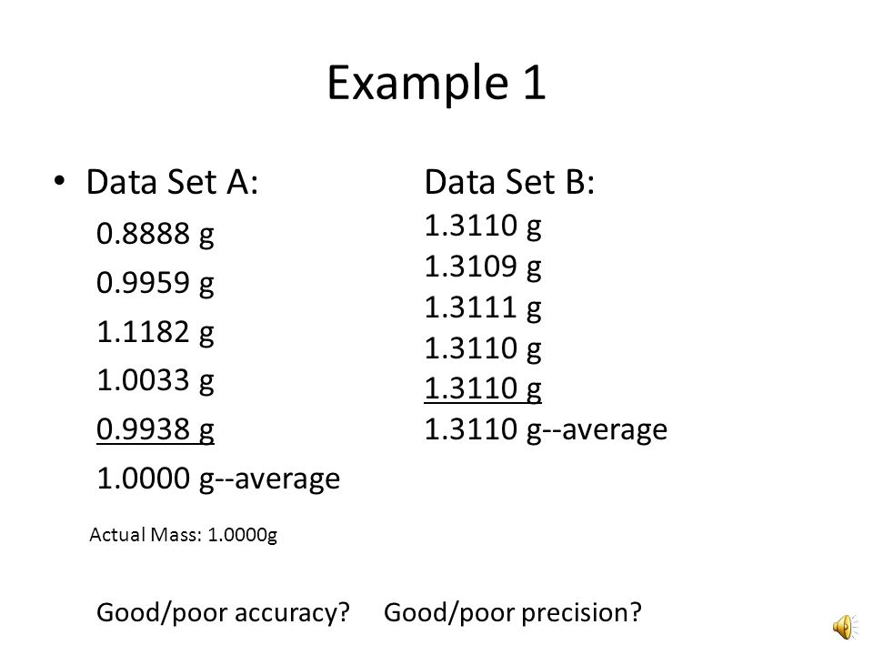What is the difference between accuracy and precision?
2. The data sets to the right are each measuring a substance that has an actual mass of 1.0001 grams.
   1. Which data set is more precise? How can you tell?
   2. Which data set is more accurate? How can you tell?
3. What is the formula for percent error?
4. If the actual mass of is 1.0001 grams,
   1. Calculate the percent error for data set A.
   2. Calculate the percent error for data set B.
5. In the same experiment where they were determining the mass above, one of the scales used was not zeroed before the experiment, so it read “-0.0201 g” before the mass was placed on the scale. How would this affect the measured mass?

**LT 1.4: Choose appropriate measurement tools and use them to report measurements with the correct number of significant figures.**

1. Name the following measurement tools:

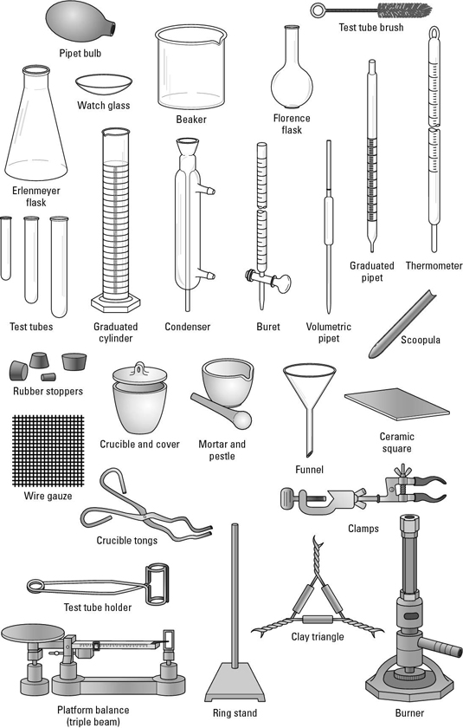   

1. State whether each of the following tools measures mass, volume, length, or temperature.
   1. ____________ thermometer
   2. ____________ triple beam balance
   3. ____________ ruler
   4. ____________ graduated cylinder
   5. ____________ beaker
   6. ____________ meter stick
   7. ____________ electronic scale
2. What is the most accurate piece of glassware for measuring *exactly* 50.0 mL of water—a beaker, graduated cylinder, or Erlenmeyer flask? Explain.
3. For each of the following, write the measurement with the correct units and significant figures.

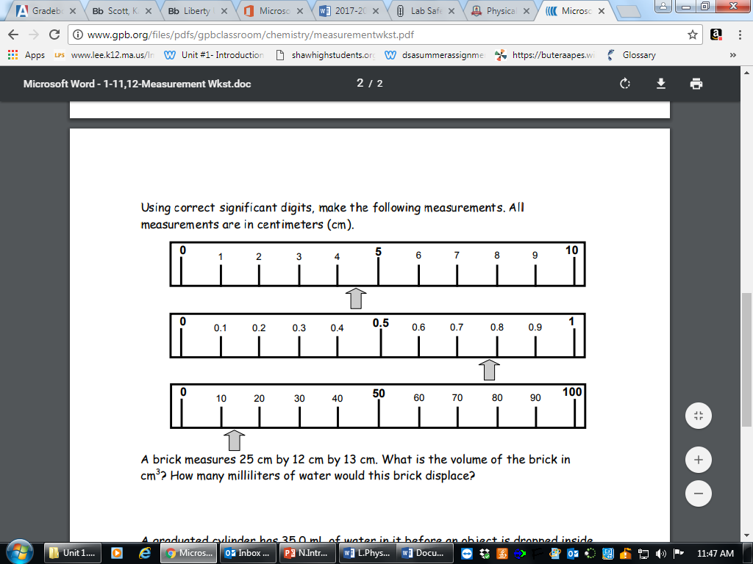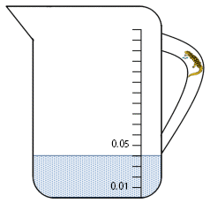

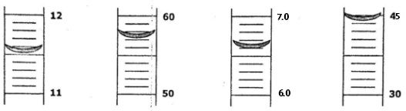

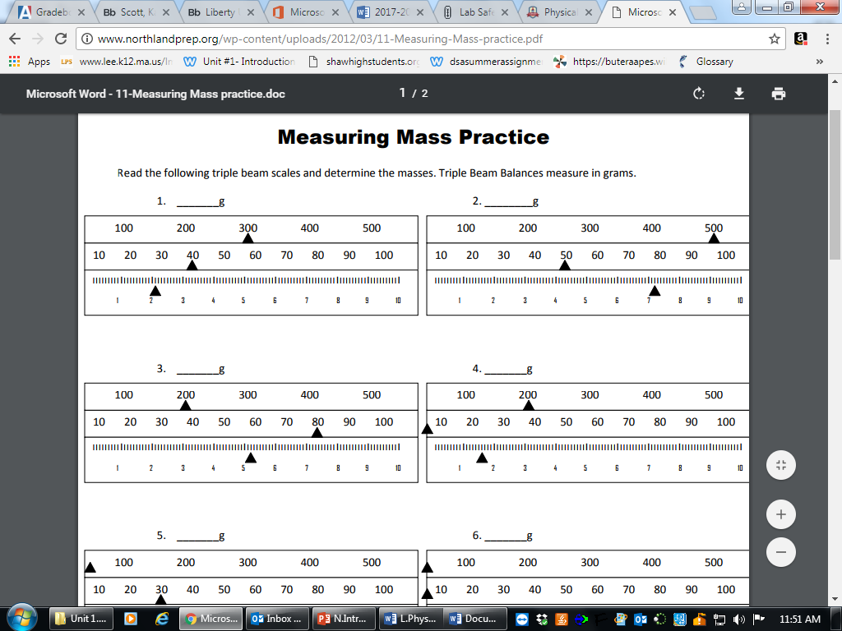

**LT 1.5: Identify types of matter and determine chemical and physical properties in matter.**

1. Define the following terms:
   1. Matter
   2. Pure substance
   3. Mixture
   4. Element
   5. Compound
   6. Chemical property
   7. Physical property
2. Identify whether each of the following are elements, compounds, or mixtures:
   1. _________ water (H2O)
   2. _________ chocolate (C6H12O6 & NaCl & …)
   3. _________ nickel (Ni)
   4. ____________ potassium fluoride (KF)
   5. ____________ tungsten (W)
   6. ____________ glass (SiO2 & Na2CO3 & …)
3. Identify whether each of the following are chemical or physical properties:
   1. ____________ melting point
   2. ____________ combustibility
   3. ____________ malleability
   4. ____________ color
   5. ____________ reaction with metal
   6. ____________ density
   7. ____________ solubility (dissolving)

**LT 1.6: Explain and model energy transfers between systems and surroundings.**

1. Identify the system and the surroundings in the following scenarios:
   1. Two liquids are mixed in a beaker and the temperature changes
   2. An ice cube melts on the counter
2. Define open, closed, and isolated systems and give an example of each.
3. 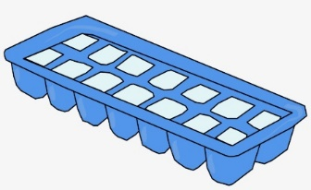You put an ice cube tray full of water into the freezer. On the image to the right, show the energy transfer—is energy entering or exiting the water as it becomes ice?
4. Label each of the following as potential or kinetic energy:
   1. _________ energy in food
   2. _________ energy from fire
   3. _________ a chandelier hanging from the ceiling
   4. _________ a rock rolling down a hill

**LT 2.1: Describe the effects of energy on particle motion of solids, liquids, and gases.**

1. Define temperature. Explain how it relates to molecular motion.
2. Which molecules have more kinetic energy—water at 100°C or water at 45°C? How do you know?
3. Draw a particle model of solids, liquids, and gases. For each one, label whether they have definite volume, definite shape, both, or neither.

**LT 2.2: Use heating and cooling curves to model changes in potential and kinetic energy as a substance goes through phase changes.**

1. Name the following phase changes:
   1. Solid to liquid
   2. Liquid to gas
   3. Gas to liquid
   4. Liquid to solid

For the following questions, refer to the heating curve to iron to the right:

1. What segment shows solid iron? _________
2. What segment shows liquid iron? _________
3. 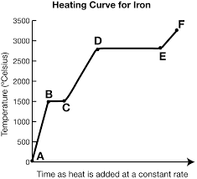What segment shows gaseous iron? _________
4. What segment shows melting? _________
5. What segment shows vaporization? _________
6. What is the melting point of iron? __________
7. What is the boiling point of iron? __________
8. Which sections show a change in kinetic energy? Explain.
9. Which sections show a change in potential energy? Explain.

**LT 2.3: Calculate a substance’s density and use density to predict whether it will float or sink in relation to another substance.**

1. Give the formula for density. What are the units?
2. If I have a substance with a mass of 1.5 g and a volume of 2.75 mL, what is the density?
3. If I have 45.9 grams of a substance with a density of 0.124 g/cm3, what is the volume?
4. 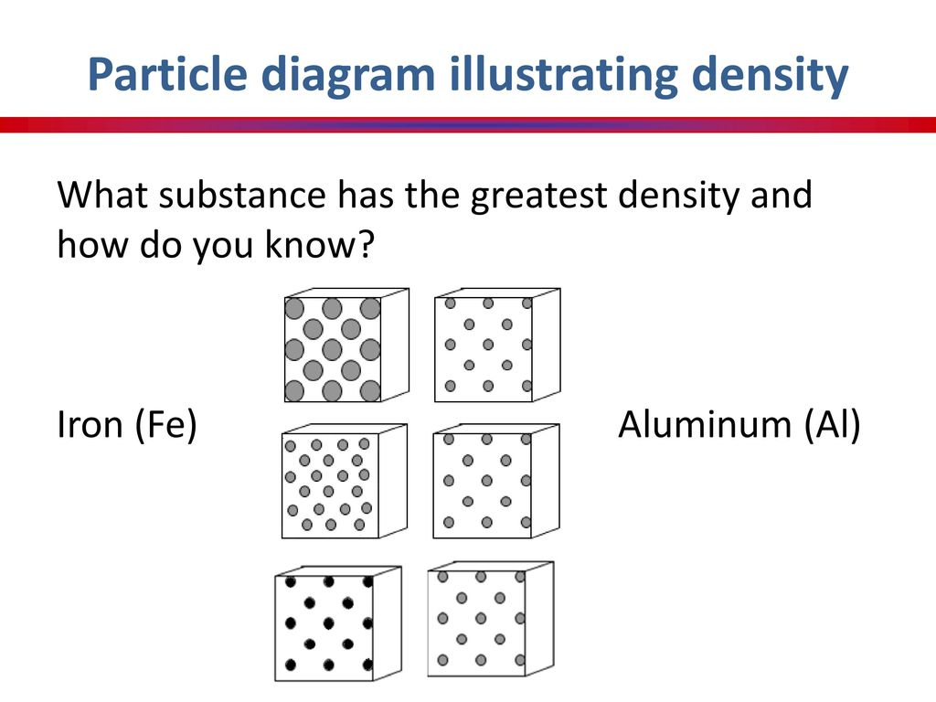If I have 278.0 mL of a substance with a density of 14.5 g/mL, what is the mass?
5. Which of the diagrams to the right is denser? Why?
6. If I pour alcohol (density 0.78 g/mL) and water (density 1.0 g/mL) into a test tube together, which one will float on top? Why?

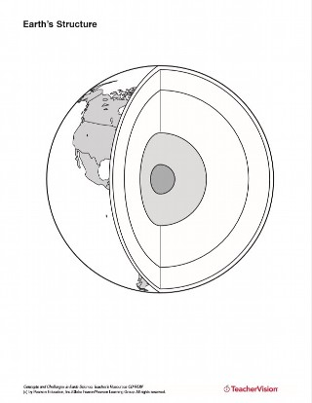**LT 2.4: Energy from the Earth’s core drives convection currents in the mantle which results in plate tectonics in the crust.**

1. On the diagram to the right, label the following:
   1. Inner core
   2. Outer core
   3. Upper mantle
   4. Lower mantle
   5. Crust
2. Why do the layers separate out this way?
3. Which layer is the densest? The hottest?
4. Name the three reasons the earth’s core is so hot.
5. Draw convection currents into the mantle.
6. How do convection currents happen? Explain using temperature and density.
7. In the diagram below, label the type of boundary, then draw convection currents below each showing how this plate boundary would be formed.

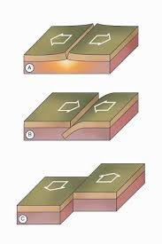

**LT 2.5 The relationship between pressure, temperature, and volume of gases can be explained and modeled using a particulate view of matter and the gas laws.**

1. Draw a model to explain what happens to pressure in a ball as the volume of the ball is increased.
2. Draw a model to explain why your tires are always a little “flatter” in the morning when it’s colder outside.
3. Draw a model to explain why as you go up in an airplane, your bag of chips expands.
4. Draw a model to explain why a warmer sample of CO2 would have a higher pressure reading.